SQL HADR TESTING

## After completion of deployment, the AG dashboard in SSMS(HA primary node) looks as below.

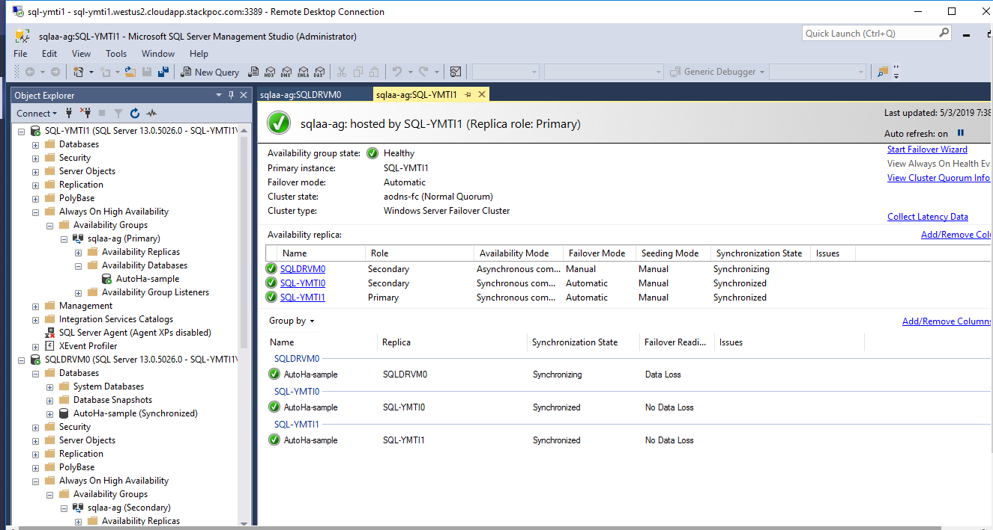

# Failover to DR Node

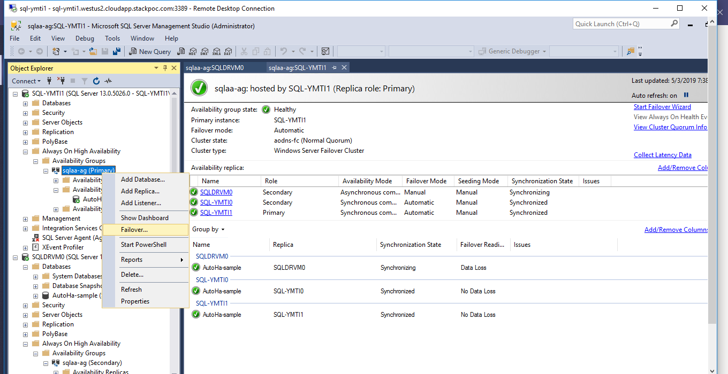

## Selecting the DR VM as Primary replica

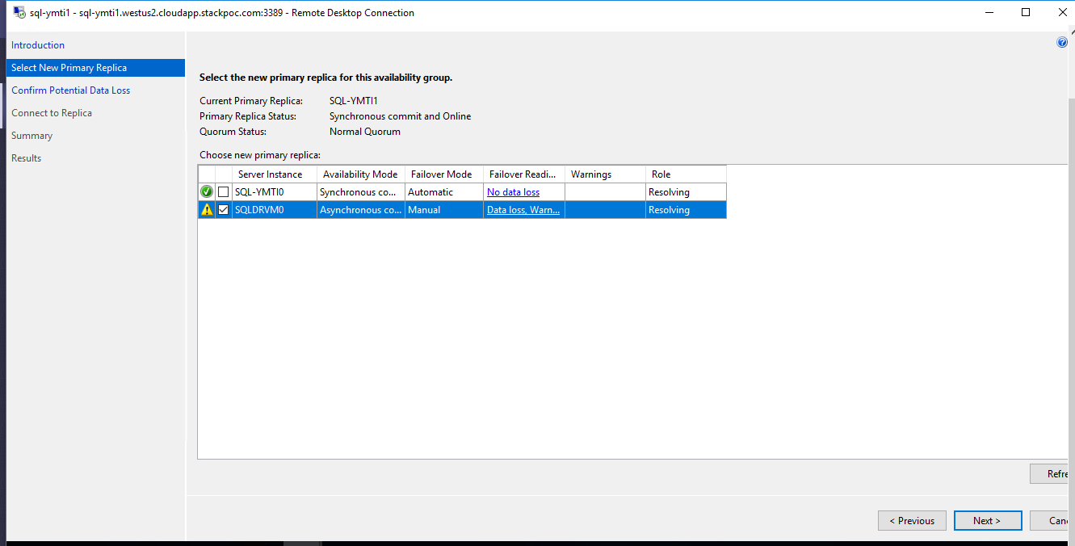

## DR Failover in progress

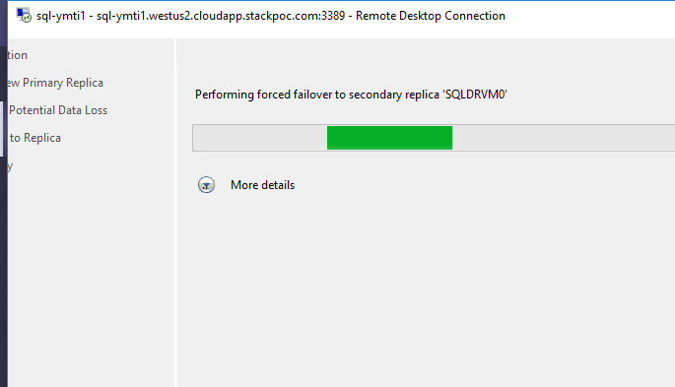

## Failover to DR VM is complete

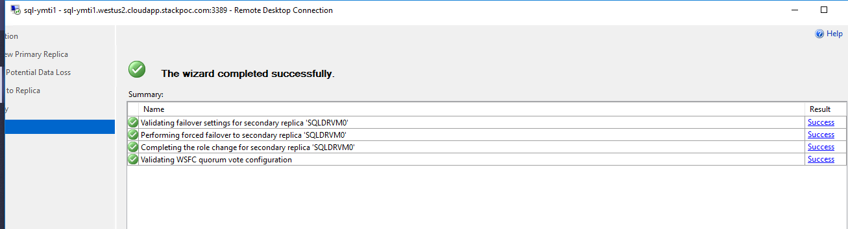

## Availability Group Dashboard, after DR VM is promoted to Primary(post Failover)

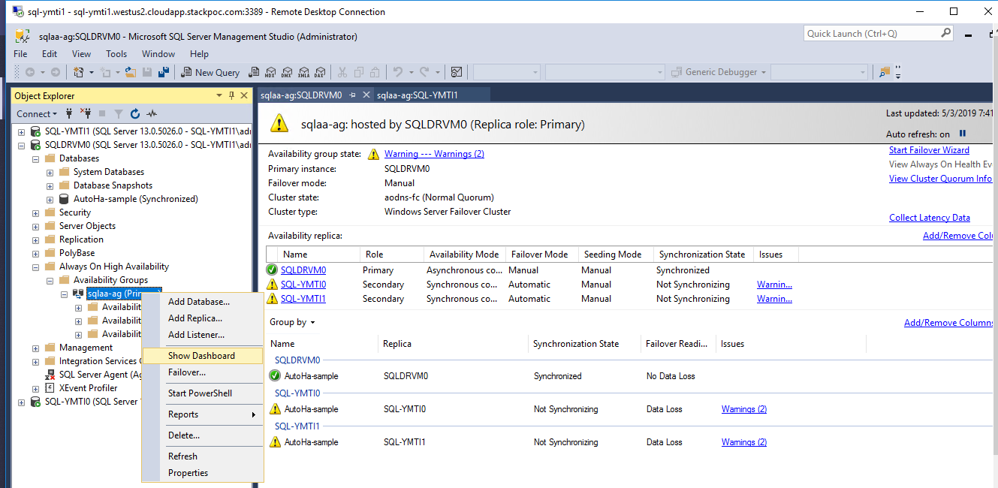

## Resume the data movement on the HA nodes (as post failover to DR Node, the Synchronization Status is ‘Not Synchronizing’)

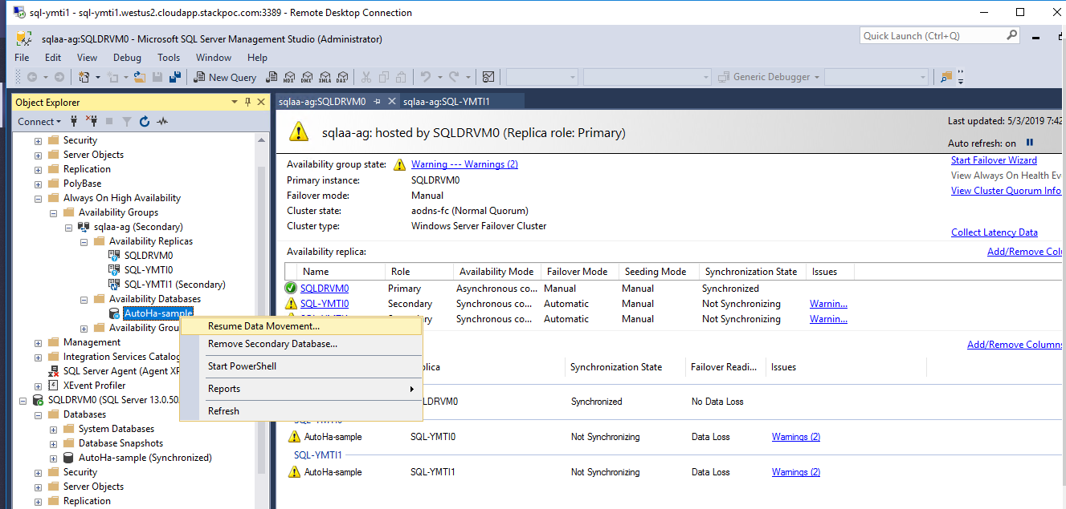

## After data movement is resumed, the availability group (HA) nodes comes into Synchronizing state.

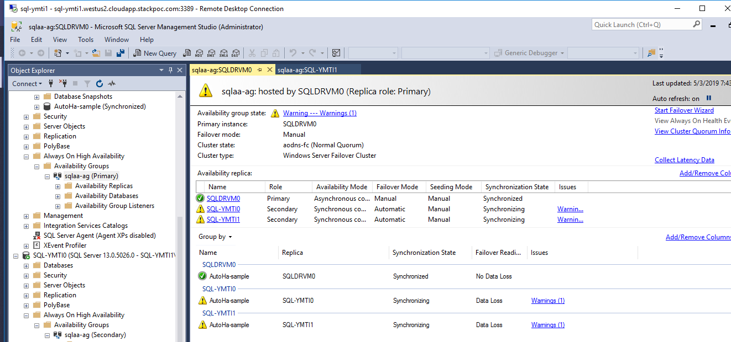

# Doing Failover back to HA Primary Node, to get back to initial state

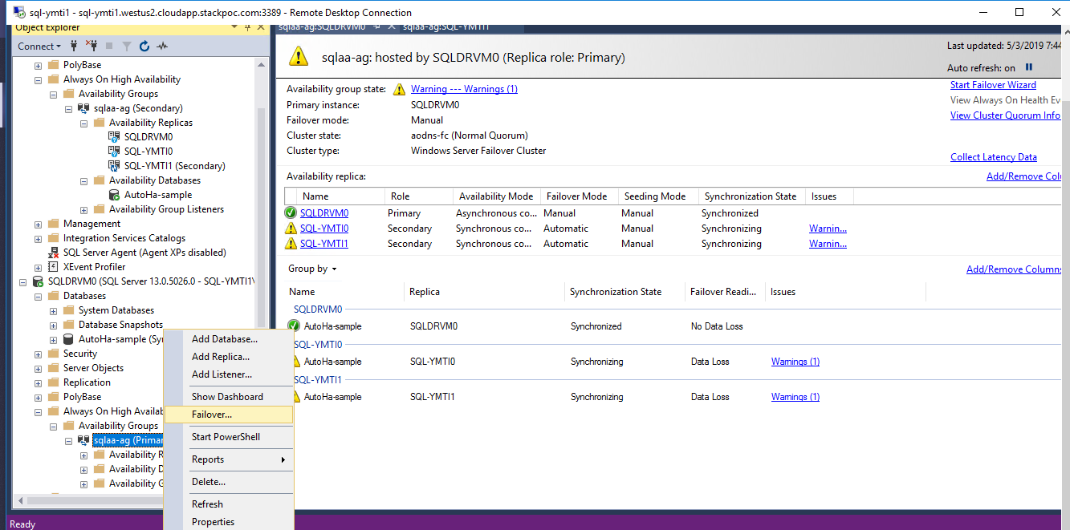

## Select the HA node as primary replica (get to initial state)

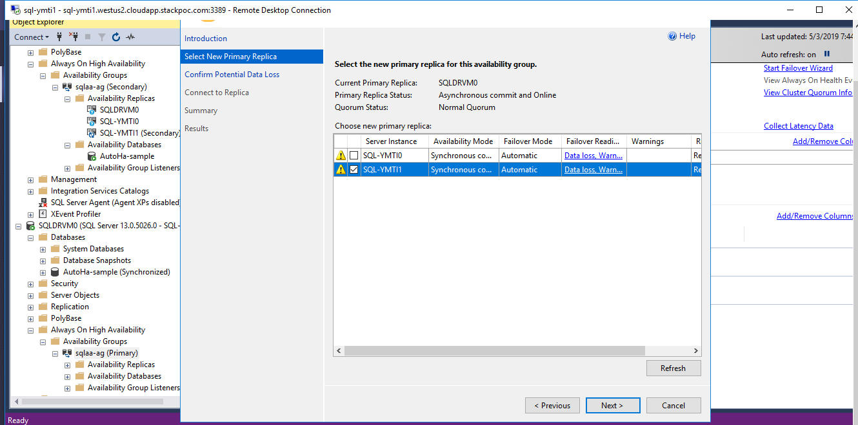

## AG dashboard after HA node becomes primary (at this point both the DR and HA secondary nodes are in ‘Not Synchronizing’ state)

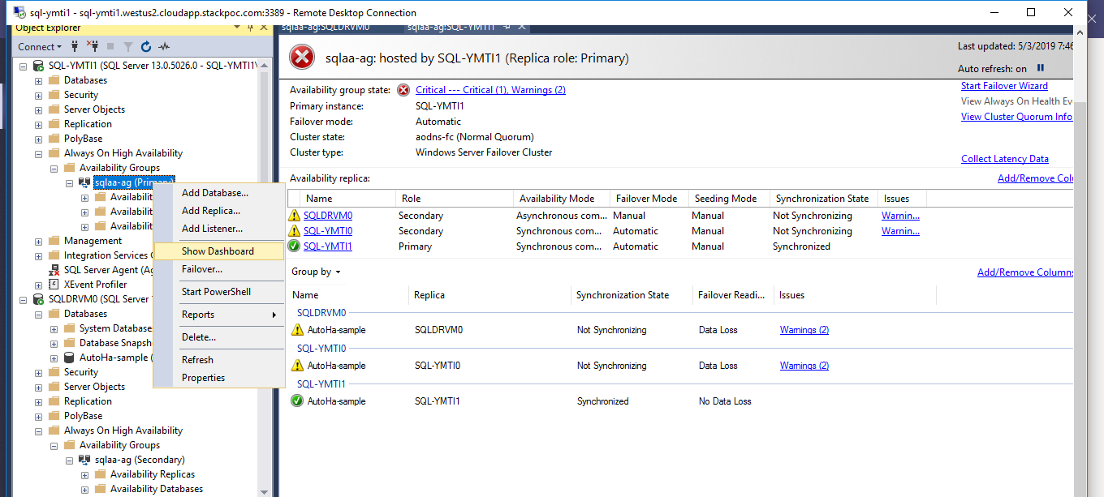

## Resume the data movement on HA secondary and DR nodes.

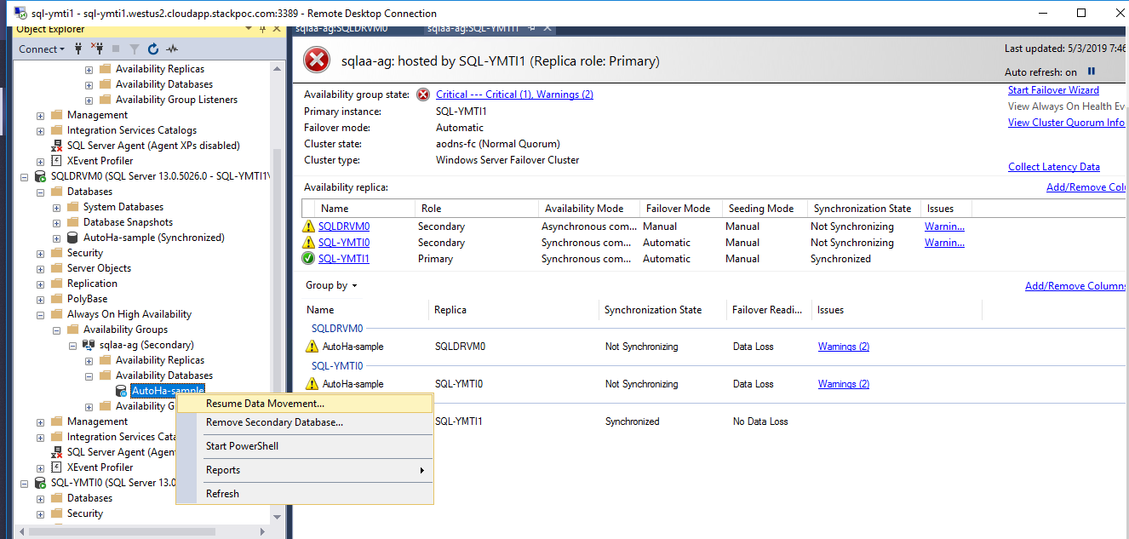

## After the data movement is resumed, the dashboard will reflect the normal state of HA

## Secondary and DR nodes

